VULNERABILITY TRACKING AND REMEDIATION SYSTEM
A Mini Project Report Submitted in partial fulfilment of the requirements for the award of the degree of

BACHELOR OF TECHNOLOGY

In
DEPARTMENT OF COMPUTER SCIENCE ENGINEERING
By
V.Praneeth – 2420030636 (Team Lead)
Y.Karthikeya – 2420030351
M.Pranith Reddy – 2420030158

Under the Esteemed Guidance of

Name of the SOA faculty of the respective section

Venkateswari Ketineni





K L (Deemed to be) University
DEPARTMENT OF COMPUTER SCIENCE ENGINEERING

DECLARATION

The Mini Project Report entitled “VULNERABILITY TRACKING AND REMEDIATION SYSTEM“is a record of Bonafide work of V. Praneeth – 2420030636, Y. Karthikeya – 2420030351, M. Pranith Reddy – 2420030158 submitted in partial fulfillment for the award of B. Tech in Computer Science and Engineering to the K L University. The results embodied in this report have not been copied from any other departments/University/Institute.

V. Praneeth – 2420030636
Y. Karthikeya – 2420030351
M. Pranith Reddy – 2420030158

K L (Deemed to be) University
DEPARTMENT OF COMPUTER SCIENCE ENGINEERING
CERTIFICATE

This is certify that the mini project based report entitled “VULNERABILITY TRACKING AND REMEDIATION SYSTEM” is a bonafide work done and submitted by V. Praneeth – 2420030636, Y. Karthikeya – 2420030351, M. Pranith Reddy – 2420030158 in partial fulfillment of the requirements for the award of the degree of BACHELOR OF TECHNOLOGY in Department of Computer Science Engineering, K L (Deemed to be University), during the academic year 2026-2027.

Signature of the Course Co-ordinator Signature of HOD

ACKNOWLEDGEMENT

The success in this project would not have been possible but for the timely help and guidance rendered by many people. Our wish to express my sincere thanks to all those who has assisted us in one way or the other for the completion of my project.

Our greatest appreciation to my guide, Dr. Venkateswari Ketineni S6, Department of Computer Science which cannot be expressed in words for her tremendous support, encouragement and guidance for this project.

We express our gratitude to Dr. P.Venkateshwar Sir (CSE), Head of the Department for Computer Science Engineering for providing us with adequate facilities, ways and means by which we are able to complete this project-based Lab.

We thank all the members of teaching and non-teaching staff members, and also who have assisted me directly or indirectly for successful completion of this project. Finally, I sincerely thank my parents, friends and classmates for their kind help and cooperation during my work.

V. Praneeth – 2420030636
Y. Karthikeya – 2420030351
M. Pranith Reddy – 2420030158

TABLE OF CONTENTS

S.No. | Contents | Page No.
1. | Abstract | 6
2. | Introduction | 7-8
3. | Literature survey | 9-10
4. | Problem Statement and Objectives | 11
5. | Hardware and Software requirements | 12-13
6. | Implementation | 14-17
7. | Results & Discussion | 18-19
8. | Conclusion & Future Scope | 20-21
9. | References | 22

- ABSTRACT
The Vulnerability Tracking and Remediation System is a security-focused software platform designed to identify, manage, prioritize, and remediate software vulnerabilities in an organized and automated manner. Modern software applications frequently depend on multiple services, libraries, APIs, and third-party components, making vulnerability management a complex and continuous process.
The proposed system follows a microservices-based architecture consisting of Authentication, User Management, Vulnerability Tracking, Remediation, Notification, and Audit services. The system uses REST APIs for service communication, Spring Cloud Gateway for API routing, Eureka for service discovery, and RabbitMQ for asynchronous messaging.
The vulnerability analysis component integrates source-code scanning using Semgrep and makes use of vulnerability-related datasets such as Devign and CVEFixes, along with CVE/NVD metadata. The platform provides a React-based dashboard through which users can monitor vulnerabilities, view severity levels, manage users and roles, initiate remediation workflows, and inspect audit logs.
An AI/LLM-assisted remediation workflow is incorporated to support developers in understanding vulnerabilities and generating potential fixes. The system aims to reduce the complexity of vulnerability management by bringing detection, prioritization, remediation, notification, and auditing into a unified platform.
Team Name: Team no 2
Team Members:
V. Praneeth – 2420030636
Y. Karthikeya – 2420030351
M. Pranith Reddy – 2420030158

- INTRODUCTION

1.1 Background
Software security has become an important aspect of modern application development. Applications are increasingly built using multiple frameworks, open-source libraries, APIs, cloud services, and distributed components. As the number of components increases, the possibility of introducing security vulnerabilities also increases.
A vulnerability may occur due to insecure coding practices, outdated dependencies, incorrect configurations, insufficient authentication, improper authorization, or other weaknesses in a software system. If these vulnerabilities are not detected and remediated in time, they may be exploited by attackers.
Traditional vulnerability management approaches often involve separate tools for vulnerability scanning, issue tracking, remediation, notification, and auditing. Managing these tools independently can make it difficult for security teams and developers to obtain a unified view of the security status of an application.
The proposed Vulnerability Tracking and Remediation System addresses this problem by providing an integrated platform for the vulnerability management lifecycle.
1.2 Overview of the Proposed System
The proposed system provides a centralized environment in which vulnerabilities can be:
- Detected through source-code analysis.
- Recorded and tracked.
- Classified according to severity.
- Assigned to appropriate users.
- Prioritized for remediation.
- Remediated using developer-supported and AI-assisted workflows.
- Communicated through notifications.
- Recorded through audit logs.
The system follows a modular microservices architecture, allowing individual services to be developed and maintained independently.
1.3 Need for the System
The major challenges addressed by the system include:
- Increasing number of software vulnerabilities.
- Difficulty in tracking vulnerabilities across different applications.
- Lack of centralized vulnerability information.
- Manual vulnerability prioritization.
- Delayed remediation.
- Lack of proper audit trails.
- Communication gaps between security teams and developers.
- Difficulty in understanding and fixing vulnerabilities.
The proposed system attempts to provide a single platform for managing these activities.

- LITERATURE SURVEY
2.1 DefectDojo – Vulnerability Management Platform
OWASP DefectDojo is an open-source application designed to streamline vulnerability management. It supports importing findings from multiple security tools, organizing vulnerabilities, tracking their lifecycle, and providing security management capabilities.
The platform demonstrates the importance of centralizing vulnerability information from different security tools. The proposed system follows a similar centralized approach while emphasizing microservices, remediation workflows, and AI-assisted fixes.
Reference: OWASP DefectDojo.
2.2 Faraday – Collaborative Vulnerability Management
Faraday provides a collaborative platform for vulnerability management and security assessment. It allows security teams to centralize security findings and organize them within a common workspace.
The project demonstrates how vulnerability findings can be collected and managed through a centralized platform. The proposed system extends this concept by incorporating dedicated services for tracking, remediation, notifications, and auditing.
Reference: Faraday Vulnerability Management.
2.3 Rapid7 InsightVM
Rapid7 InsightVM provides vulnerability management capabilities including vulnerability discovery, risk assessment, prioritization, and remediation management.
Its approach highlights the importance of prioritizing vulnerabilities according to their security impact instead of treating all vulnerabilities equally. The proposed system similarly maintains severity-based vulnerability management and remediation workflows.
2.4 Tenable One Vulnerability Management
Tenable One provides a vulnerability management approach that combines asset visibility, vulnerability identification, risk analysis, and remediation.
The platform emphasizes the importance of understanding the security posture of an organization and prioritizing vulnerabilities according to risk. The proposed system applies this concept at the application level through vulnerability tracking and remediation services.

2.5 National Vulnerability Database
The National Vulnerability Database (NVD) provides information related to publicly known cybersecurity vulnerabilities. CVE identifiers and vulnerability metadata can be used to understand vulnerability characteristics and severity.
The proposed system uses CVE/NVD-related information as part of vulnerability analysis and classification.
2.6 Common Vulnerability Scoring System
The Common Vulnerability Scoring System (CVSS) provides a standardized method for describing the severity of vulnerabilities.
CVSS enables vulnerabilities to be classified according to their potential impact and exploitability. The proposed system uses severity concepts to assist in vulnerability prioritization and remediation.
2.7 Semgrep
Semgrep is a lightweight static analysis tool that can identify security and code-quality issues in source code using rules.
The proposed system incorporates Semgrep for source-code vulnerability scanning. The scan results can be integrated into the vulnerability tracking workflow.

- Problem Statement and Objectives

3.1 Problem Statement
Modern software applications consist of numerous components, services, dependencies, and APIs. Vulnerabilities can occur at different stages of development and deployment. Existing vulnerability management processes may require multiple independent tools for scanning, tracking, remediation, notification, and auditing.
This creates several challenges:
- Vulnerabilities may be scattered across different tools.
- Security teams may have difficulty tracking vulnerability status.
- Developers may not receive timely remediation information.
- Manual prioritization can delay critical fixes.
- Vulnerability remediation may not be properly documented.
- Audit information may be distributed across multiple systems.
Therefore, there is a need for an integrated vulnerability management platform that can provide centralized vulnerability tracking, severity-based prioritization, remediation support, notifications, and auditing.
3.2 Objectives
The main objectives of the project are:
- To develop a centralized vulnerability management platform.
- To identify vulnerabilities through automated source-code scanning.
- To track vulnerabilities throughout their lifecycle.
- To classify vulnerabilities based on severity.
- To provide role-based access to users.
- To provide remediation workflows for identified vulnerabilities.
- To integrate AI/LLM assistance for potential vulnerability fixes.
- To provide notifications related to vulnerability activities.
- To maintain audit logs for security-related actions.

- HARDWARE AND SOFTWARE REQUIREMENTS
4.1 Hardware Requirements
The system does not require specialized hardware and can be developed and executed on a standard development computer.
Minimum Requirements
- Processor: Intel Core i5 or equivalent
- RAM: 8 GB or above
- Storage: 256 GB or above
- Network: Internet connection
- Display: Standard monitor
- Keyboard and mouse
Recommended Requirements
- Processor: Intel Core i5/i7 or equivalent
- RAM: 16 GB or above
- Storage: 512 GB SSD
- Stable internet connection
4.2 Software Requirements
Frontend
- React.js
- HTML
- CSS
- JavaScript
Backend
- Java
- Spring Boot
- Spring Cloud
- REST APIs
Microservices Infrastructure
- Spring Cloud Gateway
- Eureka Service Discovery
Security Analysis
- Semgrep
- CVE/NVD metadata
- Devign dataset
- CVEFixes dataset
Monitoring and Logging
- ELK Stack
Containerization and Deployment
- Docker
- Kubernetes
Development Tools
- Visual Studio Code / IntelliJ IDEA
- Git
- GitHub
- Web browser

- IMPLEMENTATION
5.1 System Architecture
The system follows a microservices-based architecture.
The major components are:
- Authentication Service
- User Management Service
- Vulnerability Tracking Service
- Remediation Service
- Notification Service
- Audit Service
- API Gateway
- Eureka Service Registry
- React Dashboard
- Vulnerability Scanner
The architecture allows each service to perform a specific responsibility while communicating with other services through APIs and asynchronous messaging.
5.2 Authentication Service
The Authentication Service manages user authentication and access to the application.
Its major responsibilities include:
- User login.
- Authentication validation.
- Access control.
- Role-based authorization.
- Secure access to application services.
Authentication ensures that only authorized users can access security-related information.

5.3 User Management Service
The User Management Service manages application users and their roles.
The service supports activities such as:
- Creating users.
- Managing user information.
- Assigning roles.
- Updating user details.
- Managing access permissions.
The dashboard provides an interface for administrators to view and manage users.
5.4 Vulnerability Tracking Service
The Vulnerability Tracking Service is one of the core components of the system.
It manages the lifecycle of identified vulnerabilities.
The service stores information such as:
- Vulnerability ID.
- Vulnerability description.
- Severity.
- Status.
- Affected component.
- Assigned user.
- Detection information.
- Remediation status.
The vulnerabilities can be categorized according to severity, such as:
- Critical
- High
- Medium
- Low
This allows security teams to focus on the most important vulnerabilities first.
5.5 Remediation Service
The Remediation Service manages the process of fixing identified vulnerabilities.
Once a vulnerability is identified, the system can provide remediation information and allow the vulnerability to progress through its remediation lifecycle.
The workflow can include:
Detected → Assigned → In Progress → Remediated → Resolved
The remediation component also supports AI/LLM-assisted workflows for generating possible solutions and helping developers understand security issues.
5.6 Notification Service
The Notification Service communicates important vulnerability-related events to users.
Examples include:
- New vulnerability detected.
- Critical vulnerability identified.
- Vulnerability assigned to a developer.
- Remediation status updated.
- Vulnerability resolved.
RabbitMQ can be used for asynchronous communication between services and the notification component.
5.7 Audit Service
The Audit Service maintains records of important activities performed within the platform.
Examples include:
- User login.
- Vulnerability creation.
- Vulnerability status changes.
- Assignment changes.
- Remediation activities.
- User management activities.
Audit logs help provide accountability and support security investigations.
5.8 API Gateway
Spring Cloud Gateway is used as the entry point for client requests.
Instead of directly accessing individual microservices, the frontend communicates through the gateway.
The gateway provides:
- Centralized routing.
- Request forwarding.
- Service abstraction.
- Centralized access control opportunities.
The architecture can therefore be represented as:
React Dashboard → API Gateway → Microservices
5.9 Eureka Service Discovery
Eureka is used for service discovery within the microservices architecture.
Each microservice can register with the Eureka server. Other services can discover registered services dynamically instead of relying entirely on hard-coded service locations.
This improves flexibility in a distributed environment.
5.10 Vulnerability Scanning Using Semgrep
Semgrep is used to analyze source code for security vulnerabilities.
The scanning process can be represented as:
Source Code → Semgrep Scanner → Security Findings → Vulnerability Tracking Service
The findings are then processed and displayed through the dashboard

- RESULTS & DISCUSSION
Figure 1: Vulnerability Tracking and Remediation Dashboard
The dashboard serves as the main interface of the VulnTrack Security Platform, providing a consolidated view of the security status of the scanned source code. It displays the total number of vulnerabilities, along with separate counts for Critical, High Severity, and Fixed/Risk Accepted vulnerabilities. In the displayed result, the system has identified 5 total vulnerabilities, including 4 high-severity vulnerabilities and 1 fixed/risk-accepted vulnerability.
The Severity Overview section visually represents the distribution of detected vulnerabilities according to their severity levels, allowing users to identify the most significant security risks quickly. The Security Workflow section presents the vulnerability lifecycle beginning with code upload and detection, helping users understand how security findings progress through the system.
The dashboard also provides a “Scan New Code” option, enabling users to submit additional source code for automated security analysis. Overall, the screenshot demonstrates that the system successfully provides a centralized security monitoring interface for vulnerability detection, severity analysis, and remediation tracking.
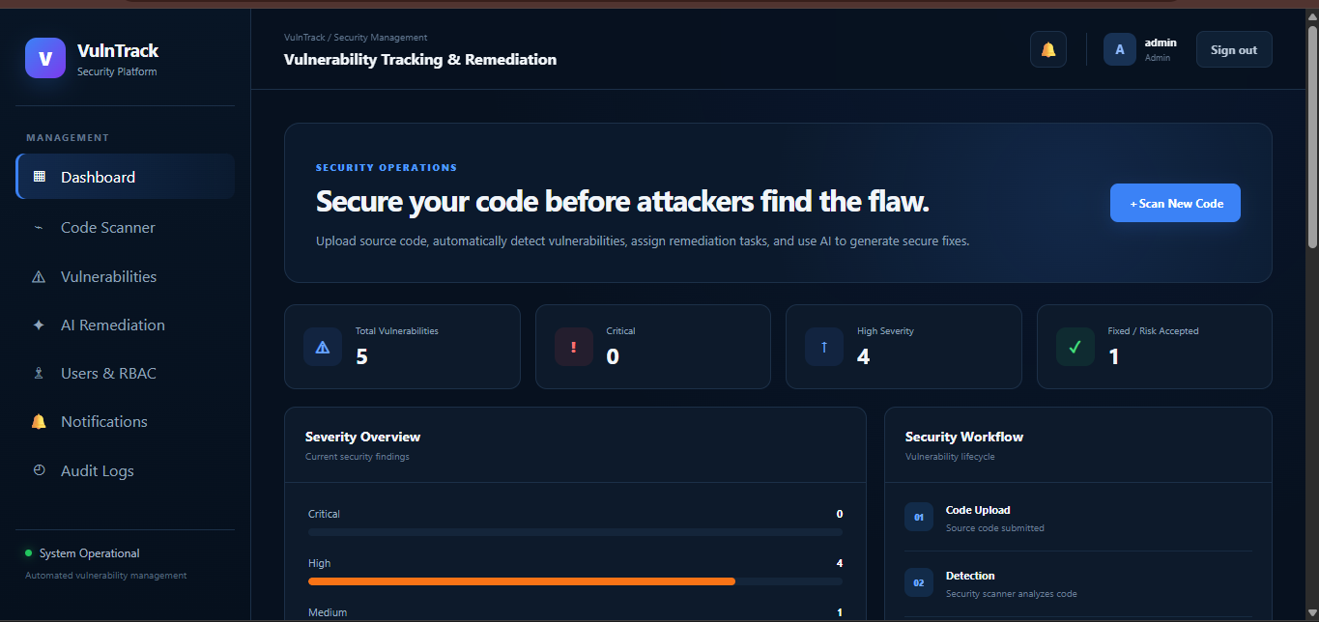

Figure 2: Vulnerability List and Recent Projects
The Vulnerability Tracking section provides a detailed view of the security issues detected during source-code analysis. Each vulnerability is displayed with its unique identifier, vulnerability name, corresponding CWE classification, affected source file, and the specific line where the issue was detected. The system also assigns a severity level, such as High or Medium, and displays the current remediation status, such as Open or Fixed.
The screenshot shows vulnerabilities including Tainted SQL Query, Request-controlled file path, Shell command execution, Weak cryptographic hash, and Possible hardcoded credential. This demonstrates that the system can identify different categories of security weaknesses within the source code and organize them according to their severity and remediation status.
The Recent Projects section provides information about the scanned project, including the number of files, lines analyzed, number of findings, and scan status. In the displayed result, the sample_vul project has been successfully scanned and 5 security findings have been identified, demonstrating the system's ability to perform automated vulnerability detection and maintain the scan results for further remediation.
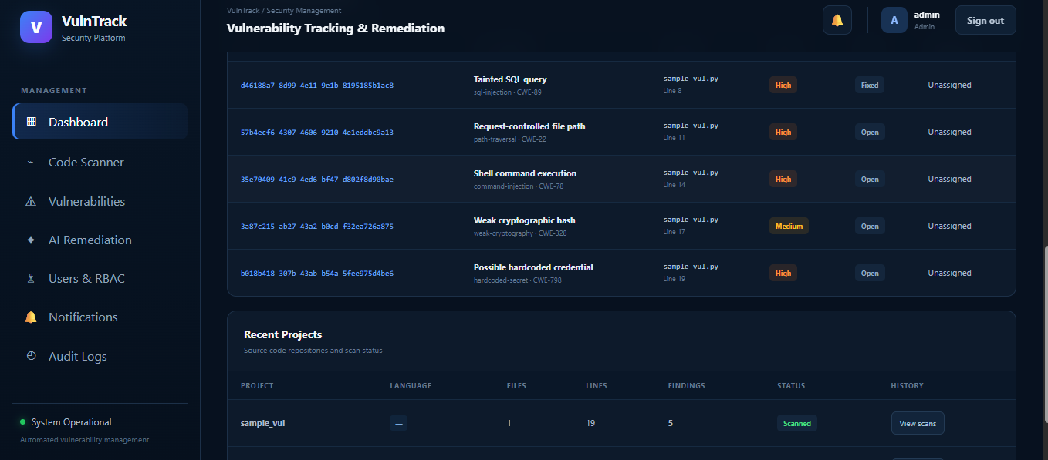

- CONCLUSION & FUTURE SCOPE
8.1 Conclusion
The Vulnerability Tracking and Remediation System provides an integrated approach to managing software vulnerabilities.
The project combines vulnerability detection, vulnerability tracking, severity classification, remediation, notification, user management, and auditing into a single platform.
The microservices architecture allows the system to remain modular and scalable. Spring Cloud Gateway provides centralized API routing, Eureka enables service discovery, and RabbitMQ supports asynchronous communication.
The React dashboard provides users with a centralized interface for monitoring vulnerabilities and managing security activities. Semgrep enables source-code vulnerability scanning, while vulnerability datasets and CVE/NVD information support vulnerability analysis.
The AI-assisted remediation workflow provides additional support to developers by helping them understand vulnerabilities and explore possible fixes.
Overall, the proposed system demonstrates how modern software engineering and security technologies can be combined to create a structured vulnerability management platform.
8.2 Future Scope
The project can be enhanced in several ways:
1. Advanced AI-Based Vulnerability Detection
Machine learning and deep learning models can be incorporated to identify complex vulnerability patterns that may not be detected using traditional rule-based scanning.
2. Automated Patch Generation
Future versions can generate automated patches for selected vulnerabilities and validate them using automated testing.
3. Cloud Deployment
The complete platform can be deployed on cloud infrastructure to support scalable vulnerability management.
4. Kubernetes-Based Deployment
The microservices can be containerized using Docker and deployed using Kubernetes for improved scalability and availability.
5. Advanced Monitoring
Prometheus and Grafana can be used to provide real-time monitoring and performance metrics.
6. Centralized Logging
The ELK Stack can be integrated to provide centralized logging and security event analysis.
7. Continuous Integration and Continuous Deployment
The vulnerability scanner can be integrated into CI/CD pipelines so that source code is automatically scanned during development and deployment.
8. Risk-Based Prioritization
Future versions can incorporate additional risk factors such as exploitability, asset importance, vulnerability exposure, and business impact.
9. Automated Notifications
Email, messaging, and real-time notification mechanisms can be added to improve communication between security teams and developers.
10. Security Analytics
Future versions can provide advanced analytics and dashboards to identify vulnerability trends and measure remediation performance.

- REFERENCES

- OWASP, DefectDojo – Vulnerability Management Platform.
https://owasp.org/www-project-defectdojo/
- DefectDojo Documentation.
https://docs.defectdojo.com/
- Faraday Security, Vulnerability Management Platform.
https://www.faradaysec.com/
- Rapid7, InsightVM Vulnerability Management.
https://www.rapid7.com/products/insightvm/
- Tenable, Tenable One Exposure Management Platform.
https://www.tenable.com/products/tenable-one
- National Institute of Standards and Technology, National Vulnerability Database (NVD).
https://nvd.nist.gov/
- FIRST, Common Vulnerability Scoring System (CVSS).
https://www.first.org/cvss/
- Semgrep, Static Analysis and Code Security.
https://semgrep.dev/
- Spring, Spring Cloud Gateway Documentation.
https://spring.io/projects/spring-cloud-gateway
- Spring, Spring Cloud Netflix / Eureka.
https://spring.io/projects/spring-cloud-netflix
- Elastic, Elastic Stack Documentation.
https://www.elastic.co/guide/
- CVEFixes, CVEFixes Dataset.
https://github.com/secure-software-engineering/cvefixes

